

Integration Tutorial

**Table of Contents:**

**Summary 2**

**Step 1 : Setup Cartridges Path 2**

**Step 2 : Upload Metadata 3**

**Step 3 : Cartridge Installation Instructions 5**

Enable Firework Cartridge **6**

**Step 4 : API Configuration 6**

Setup Your API Client on Account Manager 6

**Step 5 : Setup Site Preference 8**

**Step 6 : Firework API Configuration 8**

How to find a Shortcode & Organization ID : 10

**Step 7 : Load Firework Dashboard 10**

**Step 8 : Add Firework Widget to Storefront 13**

**Step 9 : Enable Instant Checkout 13**

SFCC OPEN API Shop Data Set 14

**Operations, Maintenance 30**

Availability 30

Support 31

# **Summary**

* No known dependency on any 3rd party product.
* The integration for this cartridge encompasses, the deployment of a generic cartridge combined with minor modification of templates inside the storefront code for the cartridge to be fully functional
* Download the Cartridge Package from Git Repository <https://github.com/loopsocial/salesforce>
* Feel free watch Tutorial Video [here](https://drive.google.com/file/d/1lskwF3HeKxwiawOGE4zEwFa29T2eCwoQ/view?usp=sharing)

# Step 1 : Setup Cartridges Path

* Now we’ll configure Cartridge Paths to ensure the Firework Cartridges are loaded. In Administration > Sites > Manage Sites > YourSite > Settings we’ll add that Cartridges includes

| **int_firework_pd:** |
| --- |

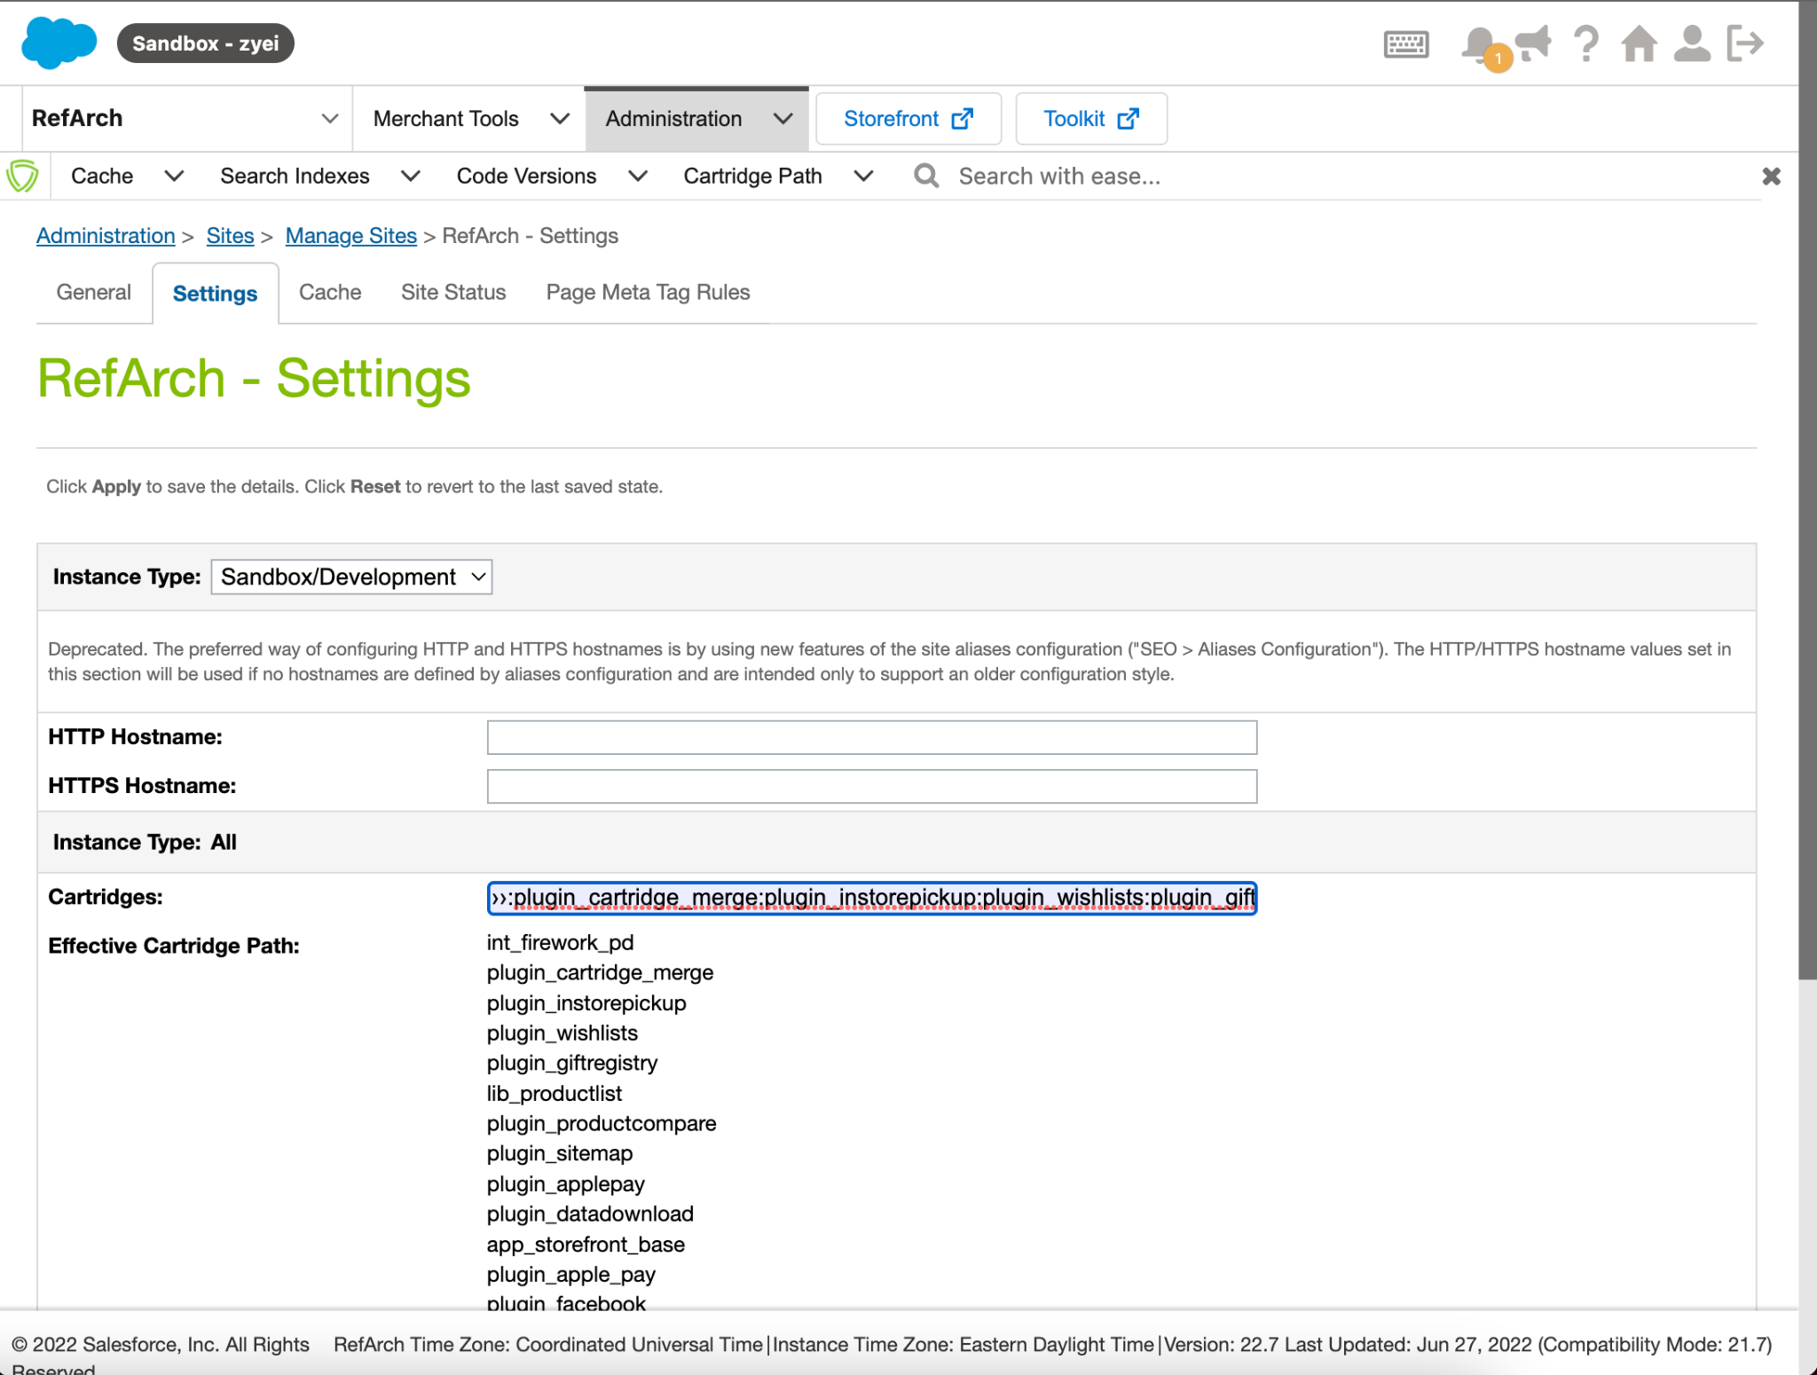

* Next, in Administration > Sites > Manage Sites > Business Manager > Settings we’ll add that Cartridges includes

| **bm_firework_pd:bm_firework_dashboard:** |
| --- |

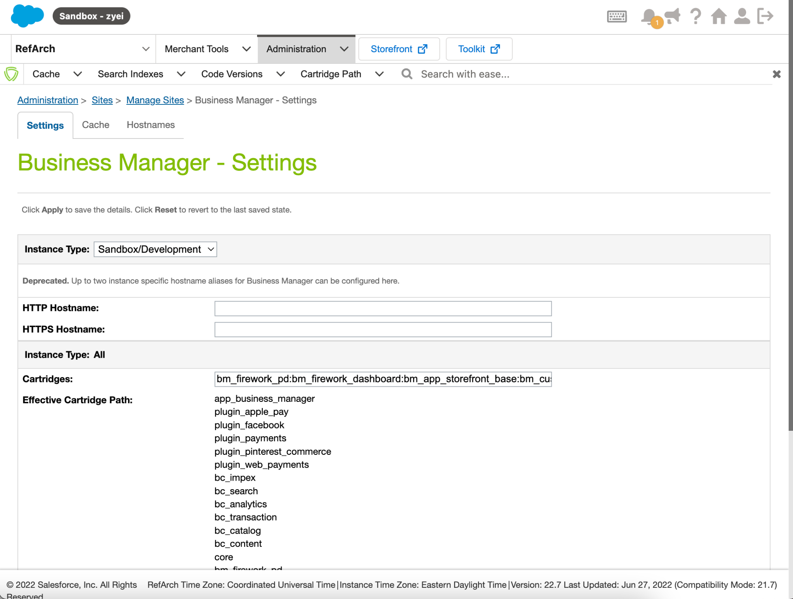

# Step 2 : Upload Metadata

After the installation of cartridge on your instance, lets upload the metadata of the integration :

Firework.zip

NOTE:

Before you import jobs please open the firework-job.xml inside the Firework.zip file and update context site-id to your desired site id

<context site-id="your_site_id"/>

* To upload the file, navigate to Administration → Site Development → Site Import & Export → Upload →Choose Firework.zip to Upload

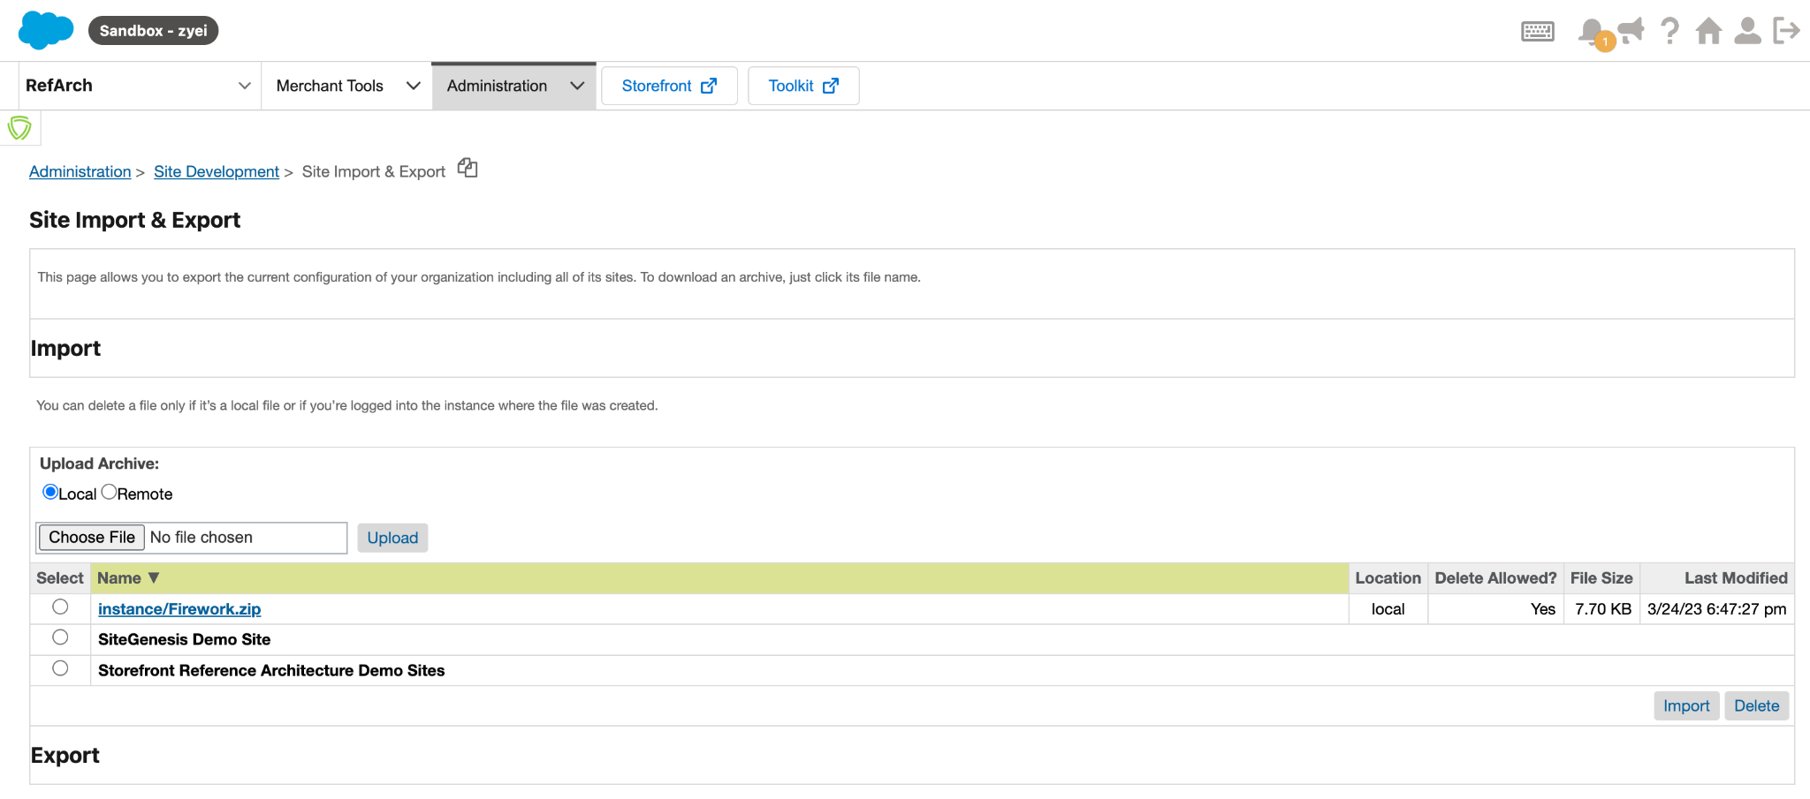

Import the metadata:

* To Import the metadata, navigate to navigate to Administration → Site Development → Site Import & Export → Select the uploaded file → Click Import

# Step 3 : Cartridge Installation Instructions

There are 3 cartridges in the zip folder

* bm_firework_dashboard
* bm_firework_pd
* int_firework_pd

Please install these 3 cartridges on your SFCC cartridges directory

### Enable Firework Cartridge

Navigate to Administration Organization Roles & Permissions Administrator Business Manager Modules

Then you can select the site or organization you want to enable the Firework Cartridge.

# Step 4 : Setup Site Preference

Please Select Store and navigate to Merchant Tools → Site Preferences → Custom Site Preference Groups → fireworkDashboardConfig

| **Name** | **Value** |
| --- | --- |
| Currency | Your Store Currency |
| Business Unique Id | Your Store Storefront URL |
| Contact Email | Your Store Contact Email |

# Step 5 : **API Configuration**

## Setup Your API Client on Account Manager

Setup API client on demandware Account Manager with following Configuration:

Login to Demandware Account Manager and Navigate to API Client → Add API Client → Setup Display Name, Password and Select Your Organization → Roles → Select your Production / Sandbox Instance for Commerce Cloud Developer Experience and Salesforce Commerce API

**Default Scopes:**

| mail  roles  tenantFilter  profile  tenant  Filter  openId |
| --- |

**Allowed Scopes:**

| sfcc.shopper-customers.register  sfcc.shopper-customers.login  sfcc.products.rw  sfcc.catalogs.rw |
| --- |

**Redirect URIs:**

| http://localhost:8080  <https://admin.us02.dx.commercecloud.salesforce.com/oauth2-redirect.html>  [https://your_admin_URL/on/demandware.store/Sites-Site/default/oauth-callback](https://your_admin_url/on/demandware.store/Sites-Site/default/oauth-callback) |
| --- |

**Important Step: Your_admin_RedirectURL** you will get it from Firework API Configuration Window:

to get Redirect URL please navigate to Select Site, Merchant Tools → Manage Firework → Firework Dashboard

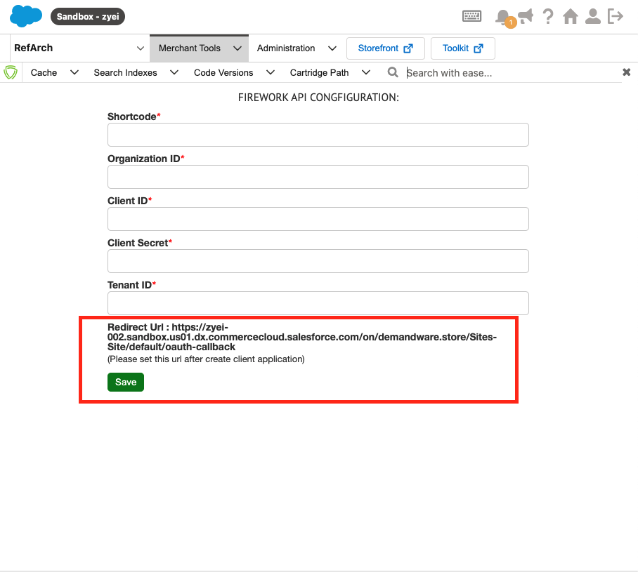

**Token Endpoint Auth Method:** private_key_jwt

**Access Token Format:** JWT

Once you click Save, it will generate the API Client ID and you need to remember the password you set during client Registration , we will need it for the next step.

# Step 6 : Firework API Configuration

To support the API Integration we need to enable the default site locale.

**Merchant Tools > Site Preferences > Locales** and select **default**

Please navigate to Select Site Merchant Tools → Manage Firework → Firework Dashboard

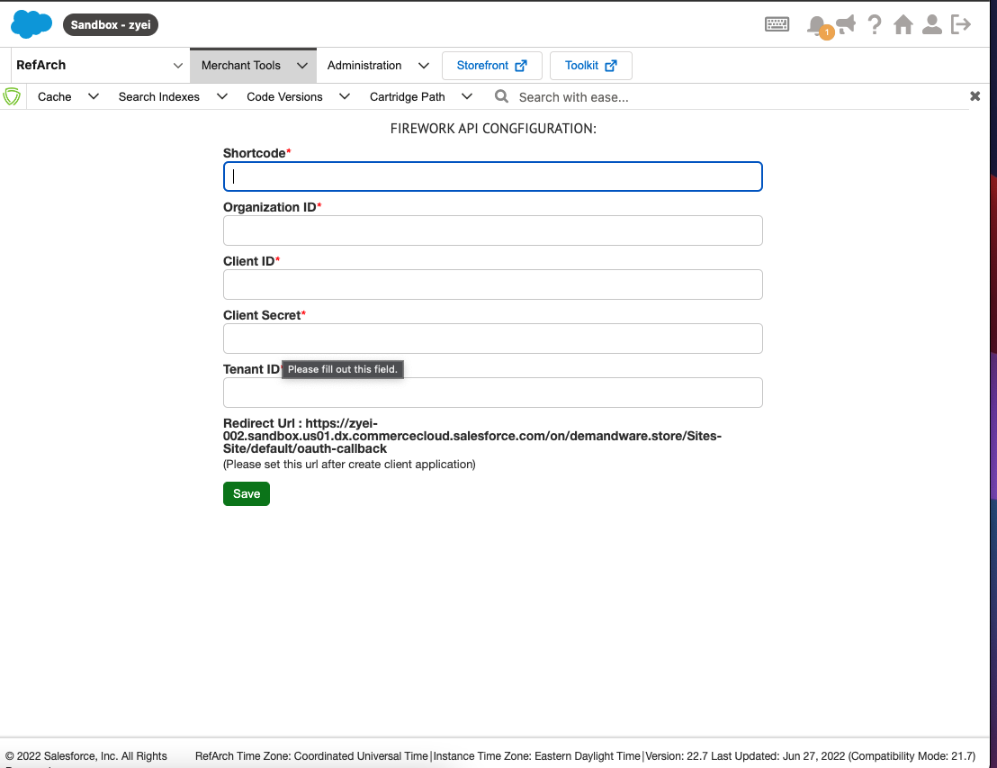

ClientID and Password you already generated in **STEP 5** we will use here.

### How to find a Shortcode & Organization ID :

Please navigate to Administration → Site Development → Salesforce Commerce API Settings

We need to get the Short code and Org ID to enable the SFCC API Communication.

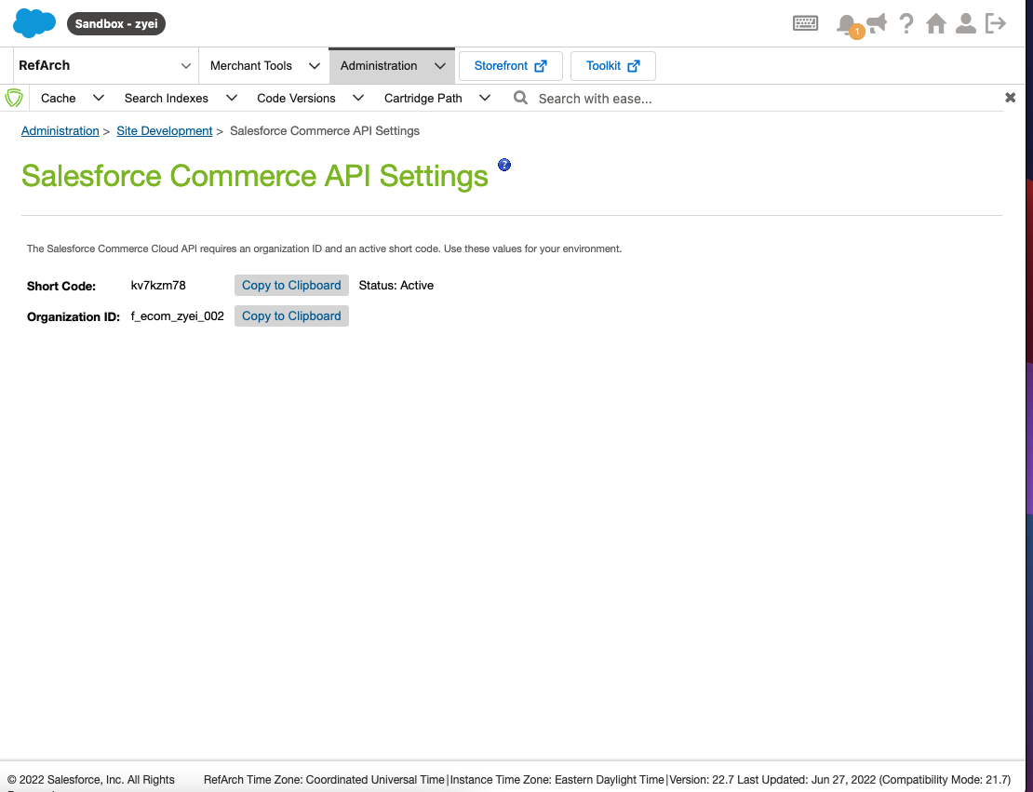

# Step 7 : **Load Firework Dashboard**

Navigate to **Merchant Tools → Manage Firework → Firework Dashboard**

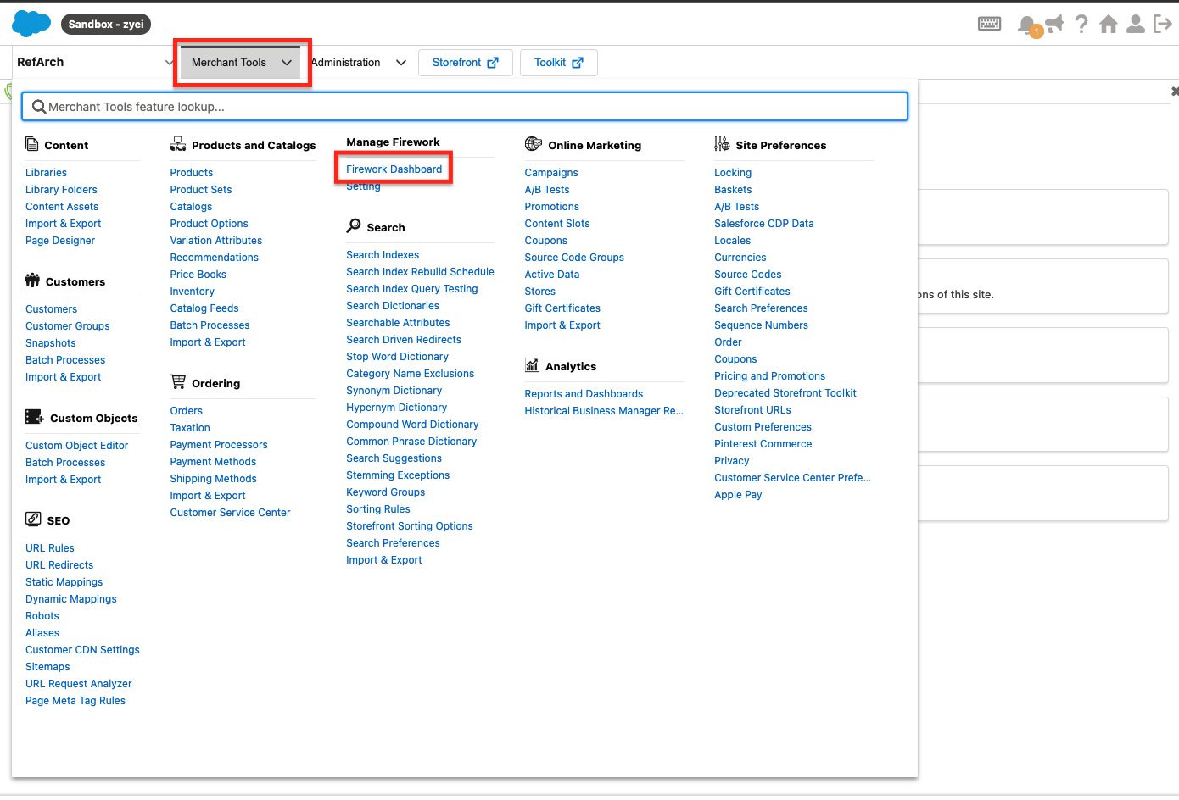

# 

1. It will ask you to Login to Your Firework Business Account.
2. Please enter your Firework email address and One time Passcode
3. After that you will be redirected to Select the Existing Business or create a new Business. After this selection you will land on the Salesforce Product Feed / Import tool page

**Here is the video guide on how to login to a Firework account.**

<https://drive.google.com/file/d/1Hyoc6VSLT5LwhXGM7M4SYcrj_oP9RGBv/view?usp=sharing>

# 

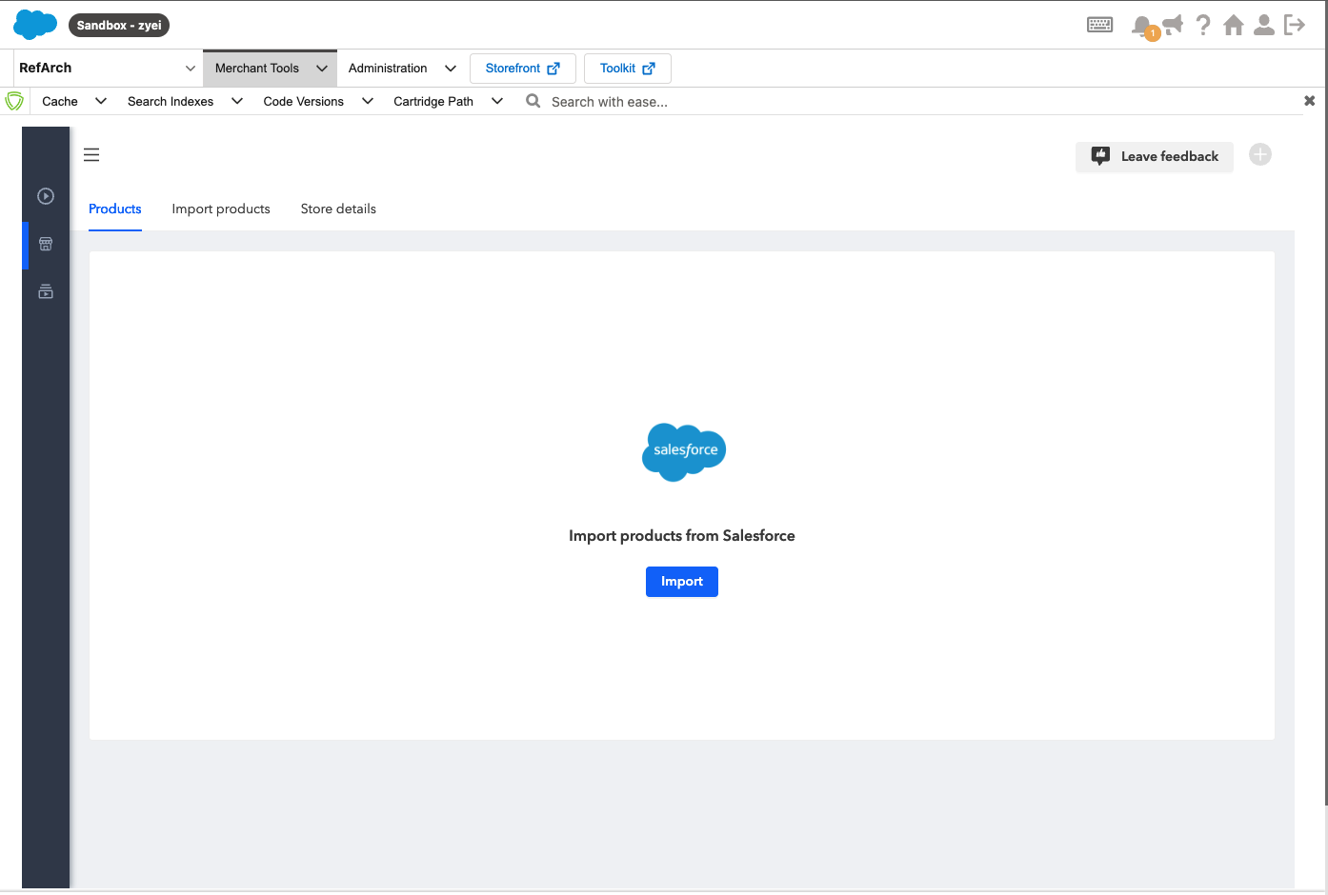

When you click Import you will get a list of all products from your salesforce store.

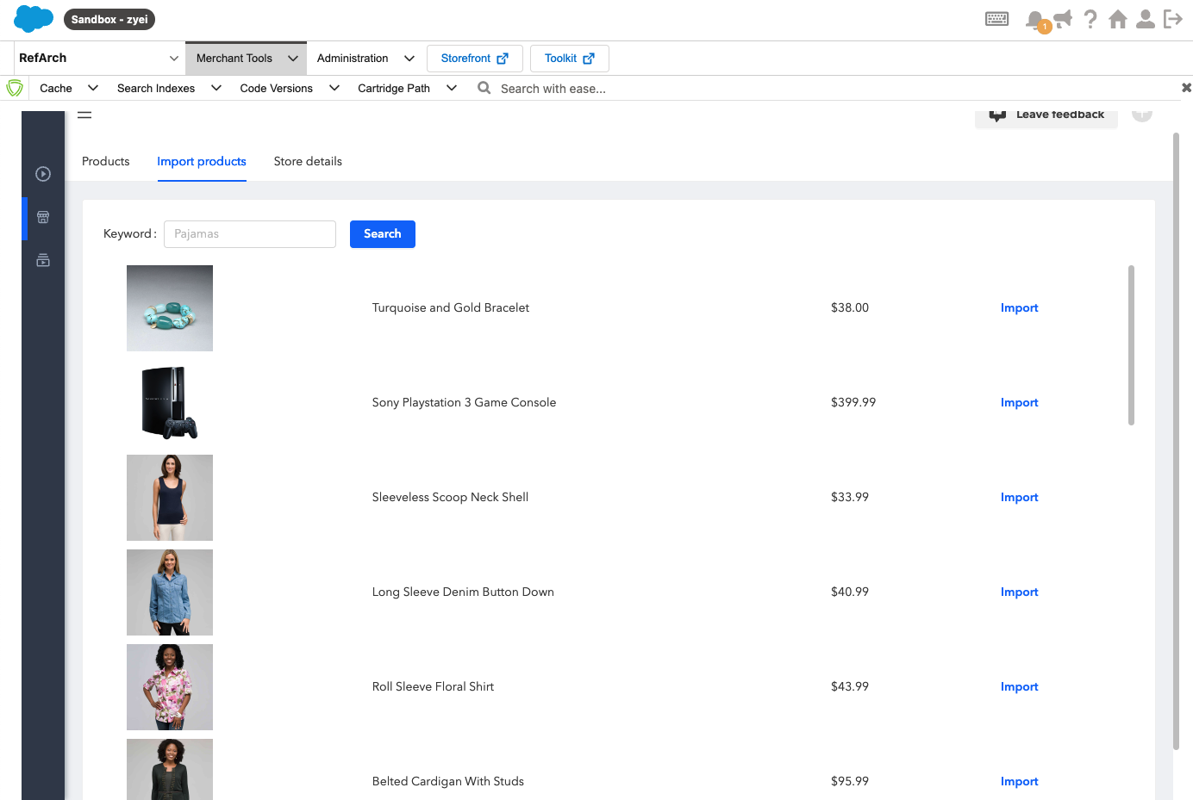

From here you can import products directly from your salesforce store to firework business store.

# Step 8 : **Add Firework Widget to Storefront**

Navigate to **Merchant Tools → Content → Page Designer**

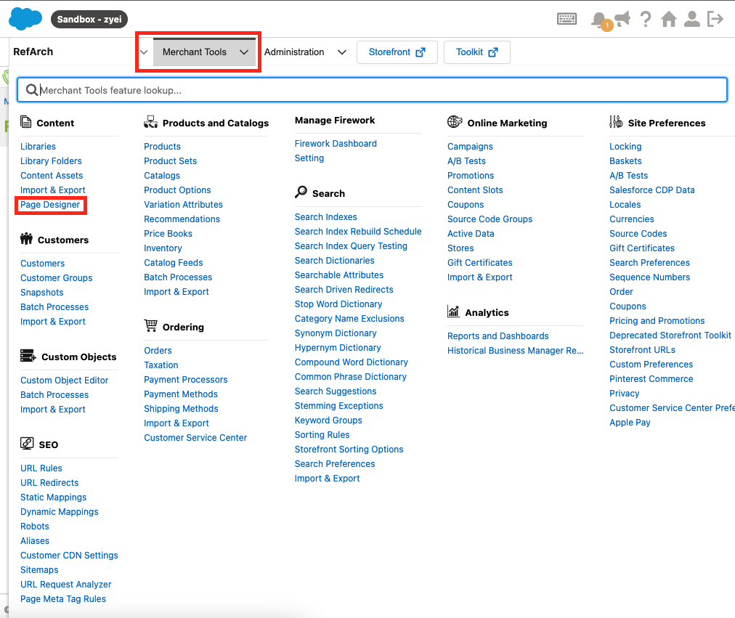

Select your Page which you want to add Widget to

You can select the layout from the Firework Components

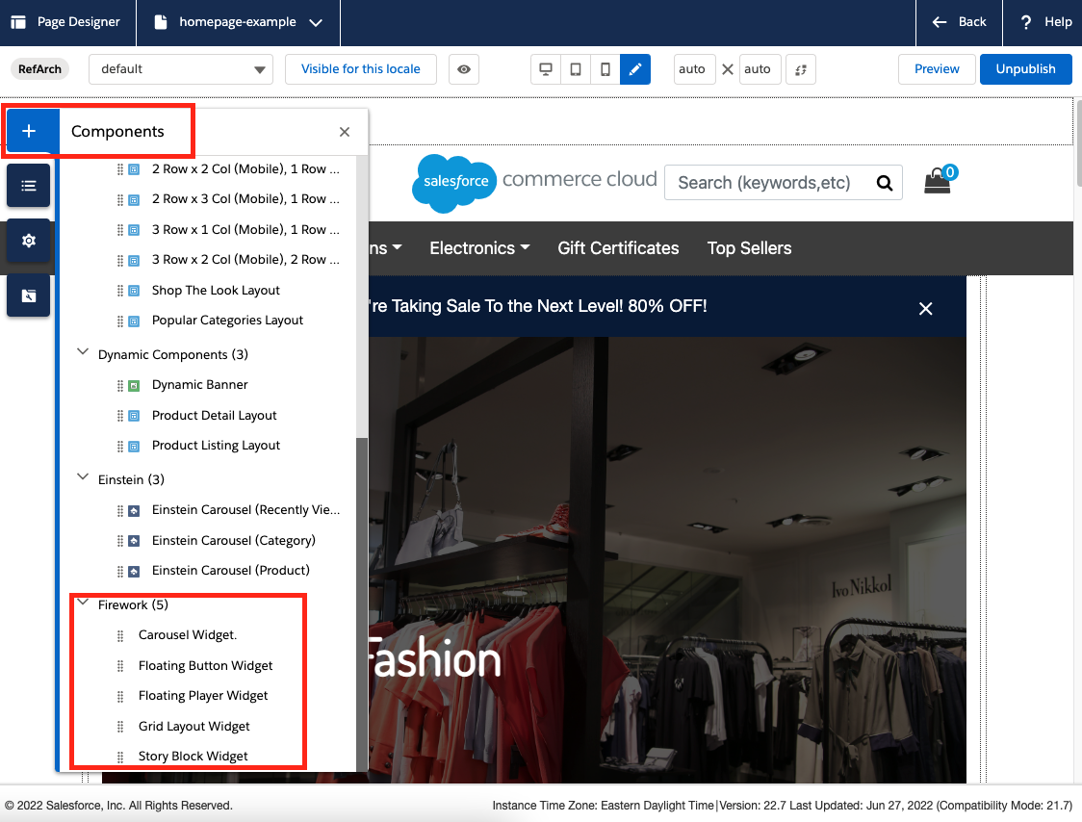

Select the Channel and Playlist from the Widget Settings:

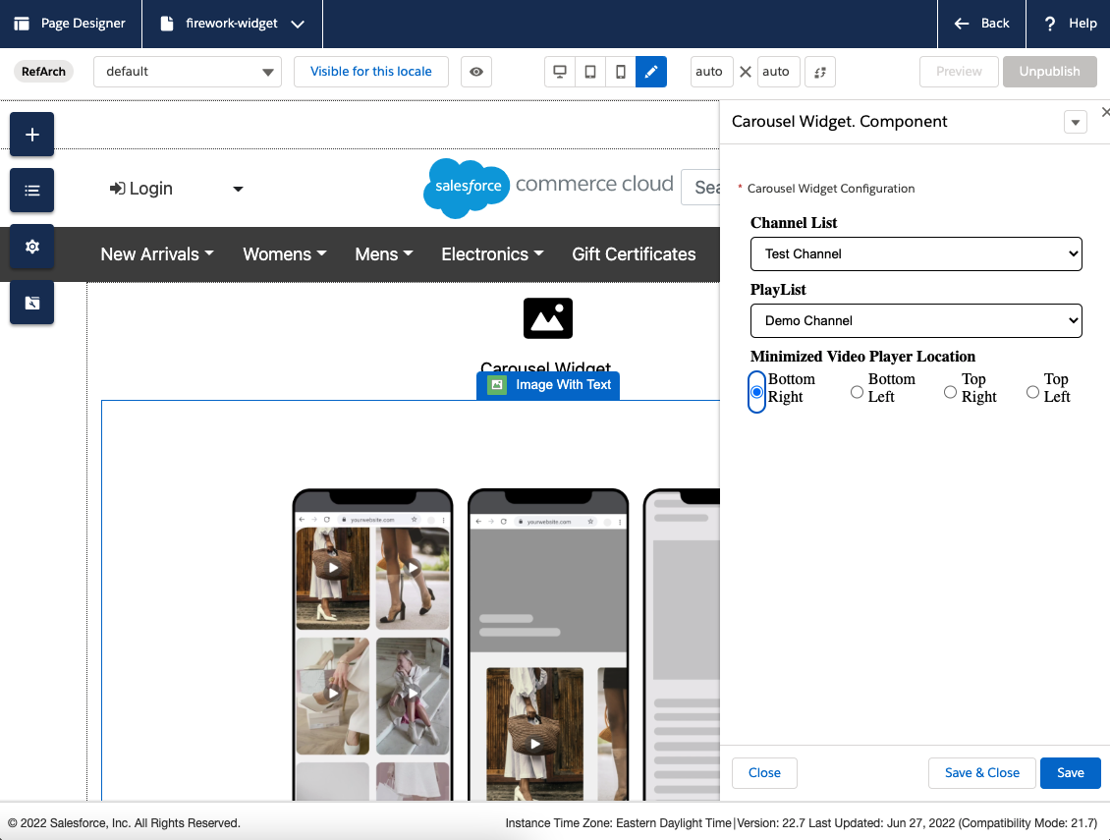

Click Save and Close, you can see the Carousel Widget added on the Page.

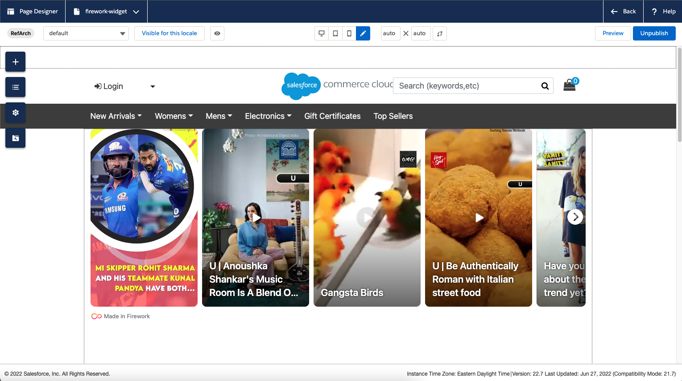

# Step 9 : Enable Instant Checkout

## SFCC OPEN API Shop Data Set

# Please set this data set into SFCC admin panel to access the OCAPI to enable the Instant / Native Cart Checkout

Navigate to the

**Administration > Site Development > Open Commerce API Settings**

**Just replace {{your_client_id}}**

{

"_v": "22.4",

"clients": [

{

"client_id": "{{your_client_id}}",

"resources": [

{

"resource_id": "/sessions",

"methods": [

"post"

],

"read_attributes": "(**)",

"write_attributes": "(**)"

},

{

"resource_id": "/baskets/{basket_id}",

"methods": [

"get"

],

"read_attributes": "(**)",

"write_attributes": "(**)"

},

{

"resource_id": "/baskets",

"methods": [

"post"

],

"read_attributes": "(**)",

"write_attributes": "(**)"

},

{

"resource_id": "/baskets/{basket_id}/storefront",

"methods": [

"put"

],

"read_attributes": "(**)",

"write_attributes": "(**)"

},

{

"resource_id": "/customers/auth",

"methods": [

"post"

],

"read_attributes": "(**)",

"write_attributes": "(**)"

},

{

"resource_id": "/baskets/reference",

"methods": [

"post"

],

"read_attributes": "(**)",

"write_attributes": "(**)"

},

{

"resource_id": "/baskets/*",

"methods": [

"get",

"patch",

"delete"

],

"read_attributes": "(**)",

"write_attributes": "(**)"

},

{

"resource_id": "/baskets/*/billing_address",

"methods": [

"put"

],

"read_attributes": "(**)",

"write_attributes": "(**)"

},

{

"resource_id": "/baskets/*/coupons",

"methods": [

"post"

],

"read_attributes": "(**)",

"write_attributes": "(**)"

},

{

"resource_id": "/baskets/*/coupons/*",

"methods": [

"delete"

],

"read_attributes": "(**)",

"write_attributes": "(**)"

},

{

"resource_id": "/baskets/*/customer",

"methods": [

"put"

],

"read_attributes": "(**)",

"write_attributes": "(**)"

},

{

"resource_id": "/baskets/*/gift_certificate_items",

"methods": [

"post"

],

"read_attributes": "(**)",

"write_attributes": "(**)"

},

{

"resource_id": "/baskets/*/gift_certificate_items/*",

"methods": [

"delete",

"patch"

],

"read_attributes": "(**)",

"write_attributes": "(**)"

},

{

"resource_id": "/baskets/*/items",

"methods": [

"post"

],

"read_attributes": "(**)",

"write_attributes": "(**)"

},

{

"resource_id": "/baskets/*/items/*",

"methods": [

"delete",

"patch"

],

"read_attributes": "(**)",

"write_attributes": "(**)"

},

{

"resource_id": "/baskets/*/payment_instruments",

"methods": [

"post"

],

"read_attributes": "(**)",

"write_attributes": "(**)"

},

{

"resource_id": "/baskets/*/payment_instruments/*",

"methods": [

"delete",

"patch"

],

"read_attributes": "(**)",

"write_attributes": "(**)"

},

{

"resource_id": "/baskets/*/payment_methods",

"methods": [

"get"

],

"read_attributes": "(**)",

"write_attributes": "(**)"

},

{

"resource_id": "/baskets/*/shipments",

"methods": [

"post"

],

"read_attributes": "(**)",

"write_attributes": "(**)"

},

{

"resource_id": "/baskets/*/shipments/*",

"methods": [

"delete",

"patch"

],

"read_attributes": "(**)",

"write_attributes": "(**)"

},

{

"resource_id": "/baskets/*/shipments/*/shipping_address",

"methods": [

"put"

],

"read_attributes": "(**)",

"write_attributes": "(**)"

},

{

"resource_id": "/baskets/*/shipments/*/shipping_method",

"methods": [

"put"

],

"read_attributes": "(**)",

"write_attributes": "(**)"

},

{

"resource_id": "/baskets/*/shipments/*/shipping_methods",

"methods": [

"get"

],

"read_attributes": "(**)",

"write_attributes": "(**)"

},

{

"resource_id": "/orders",

"methods": [

"post"

],

"read_attributes": "(**)",

"write_attributes": "(**)"

},

{

"resource_id": "/orders/*",

"methods": [

"get"

],

"read_attributes": "(**)",

"write_attributes": "(**)"

},

{

"resource_id": "/orders/*/payment_instruments",

"methods": [

"post"

],

"read_attributes": "(**)",

"write_attributes": "(**)"

},

{

"resource_id": "/orders/*/payment_instruments/*",

"methods": [

"delete",

"patch"

],

"read_attributes": "(**)",

"write_attributes": "(**)"

},

{

"resource_id": "/orders/*/payment_methods",

"methods": [

"get"

],

"read_attributes": "(**)",

"write_attributes": "(**)"

},

{

"resource_id": "/customers",

"methods": [

"post"

],

"read_attributes": "(**)",

"write_attributes": "(**)"

},

{

"resource_id": "/customers/auth",

"methods": [

"post",

"delete"

],

"read_attributes": "(**)",

"write_attributes": "(**)"

},

{

"resource_id": "/customers/auth/trustedsystem",

"methods": [

"post"

],

"read_attributes": "(**)",

"write_attributes": "(**)"

},

{

"resource_id": "/customers/*",

"methods": [

"get",

"patch"

],

"read_attributes": "(**)",

"write_attributes": "(**)"

},

{

"resource_id": "/customers/*/addresses",

"methods": [

"get",

"post"

],

"read_attributes": "(**)",

"write_attributes": "(**)"

},

{

"resource_id": "/customers/*/addresses/*",

"methods": [

"get"

],

"read_attributes": "(**)",

"write_attributes": "(**)"

},

{

"resource_id": "/customers/*/baskets",

"methods": [

"get"

],

"read_attributes": "(**)",

"write_attributes": "(**)"

},

{

"resource_id": "/customers/*/orders",

"methods": [

"get"

],

"read_attributes": "(**)",

"write_attributes": "(**)"

},

{

"resource_id": "/customers/*/password",

"methods": [

"put"

],

"read_attributes": "(**)",

"write_attributes": "(**)"

},

{

"resource_id": "/customers/*/payment_instruments",

"methods": [

"get",

"post"

],

"read_attributes": "(**)",

"write_attributes": "(**)"

},

{

"resource_id": "/customers/*/payment_instruments/*",

"methods": [

"get",

"delete"

],

"read_attributes": "(**)",

"write_attributes": "(**)"

},

{

"resource_id": "/customers/*/product_lists",

"methods": [

"get",

"post"

],

"read_attributes": "(**)",

"write_attributes": "(**)"

},

{

"resource_id": "/customers/*/product_lists/*",

"methods": [

"get",

"patch",

"delete"

],

"read_attributes": "(**)",

"write_attributes": "(**)"

},

{

"resource_id": "/customers/*/product_lists/*/items",

"methods": [

"get",

"post"

],

"read_attributes": "(**)",

"write_attributes": "(**)"

},

{

"resource_id": "/customers/*/product_lists/*/items/*",

"methods": [

"get",

"patch",

"delete"

],

"read_attributes": "(**)",

"write_attributes": "(**)"

},

{

"resource_id": "/product_lists",

"methods": [

"get"

],

"read_attributes": "(**)",

"write_attributes": "(**)"

},

{

"resource_id": "/product_lists/*",

"methods": [

"get"

],

"read_attributes": "(**)",

"write_attributes": "(**)"

},

{

"resource_id": "/product_lists/*/items",

"methods": [

"get"

],

"read_attributes": "(**)",

"write_attributes": "(**)"

},

{

"resource_id": "/product_lists/*/items/*",

"methods": [

"get"

],

"read_attributes": "(**)",

"write_attributes": "(**)"

},

{

"resource_id": "/product_search",

"methods": [

"get"

],

"read_attributes": "(**)",

"write_attributes": "(**)"

},

{

"resource_id": "/search_suggestion",

"methods": [

"get"

],

"read_attributes": "(**)",

"write_attributes": "(**)"

},

{

"resource_id": "/products/*",

"methods": [

"get"

],

"read_attributes": "(**)",

"write_attributes": "(**)"

},

{

"resource_id": "/categories/*",

"methods": [

"get"

],

"read_attributes": "(**)",

"write_attributes": "(**)"

},

{

"resource_id": "/gift_certificate",

"methods": [

"post"

],

"read_attributes": "(**)",

"write_attributes": "(**)"

},

{

"resource_id": "/promotions",

"methods": [

"get"

],

"read_attributes": "(**)",

"write_attributes": "(**)"

},

{

"resource_id": "/promotions/*",

"methods": [

"get"

],

"read_attributes": "(**)",

"write_attributes": "(**)"

},

{

"resource_id": "/stores",

"methods": [

"get"

],

"read_attributes": "(**)",

"write_attributes": "(**)"

},

{

"resource_id": "/stores/*",

"methods": [

"get"

],

"read_attributes": "(**)",

"write_attributes": "(**)"

},

{

"resource_id": "/content/*",

"methods": [

"get"

],

"read_attributes": "(**)",

"write_attributes": "(**)"

},

{

"resource_id": "/content_search",

"methods": [

"get"

],

"read_attributes": "(**)",

"write_attributes": "(**)"

}

]

}

]

}

We made few changes to the core level of the cartridge so for that reason it is required to uninstall the Existing Metadata, Services and jobs and install the cartridge again.

**Step 1:**

Please navigate to **Administration > Site Development > Custom Object Types** and delete the following object types:

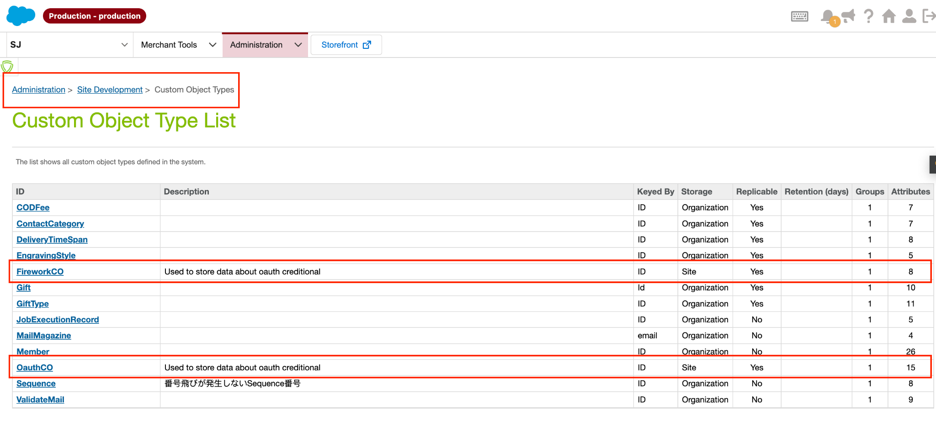

**Step 2 Delete Existing Firework Services:**

Navigate to **Administration > Operations > Services** and delete the following services:

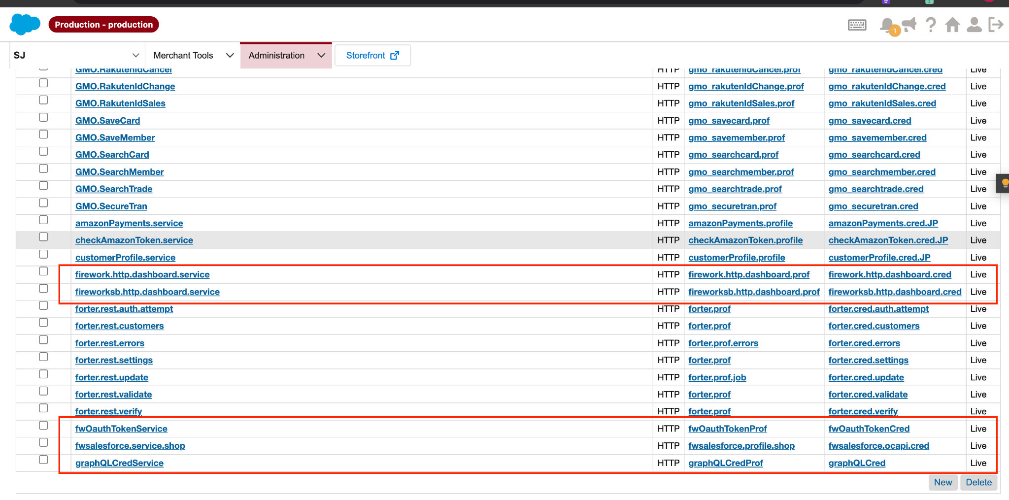

**Step 3 Delete Existing Firework Service Profiles:**

Navigate to **Administration > Operations > Services > Service Profiles** and delete following profiles:

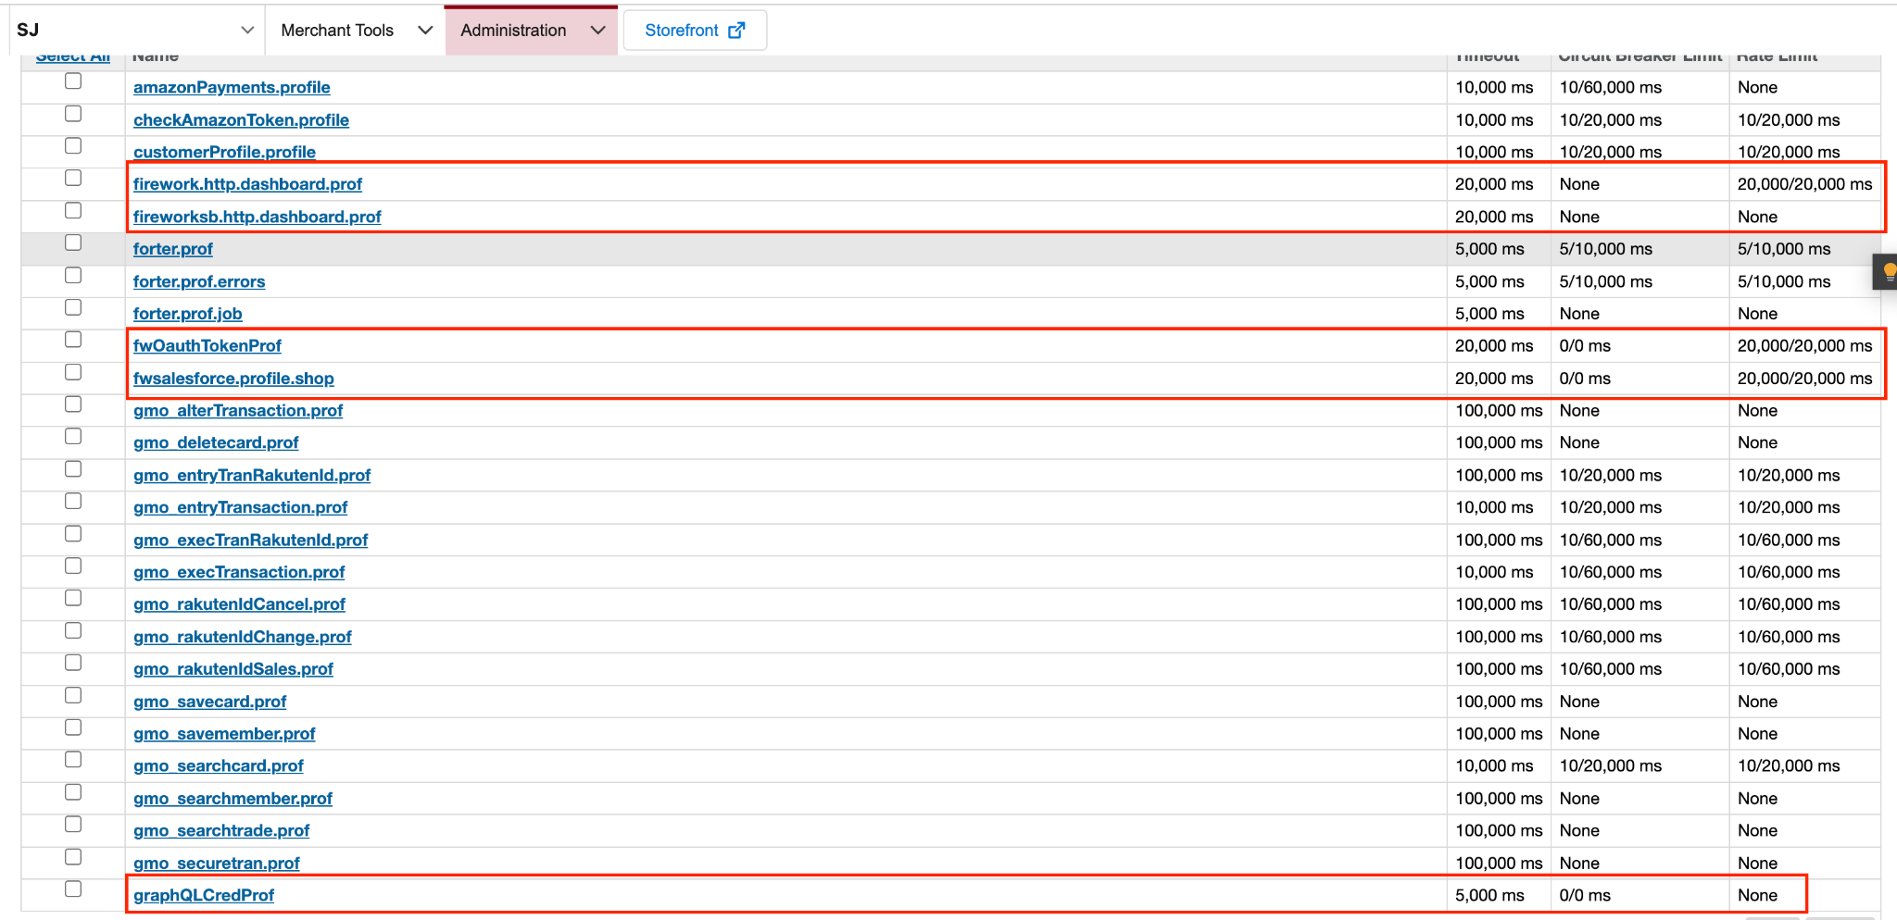

**Step 4 Existing Firework Service Credentials:**

Navigate to **Administration > Operations > Services > Service Credentials** and delete following credentials:

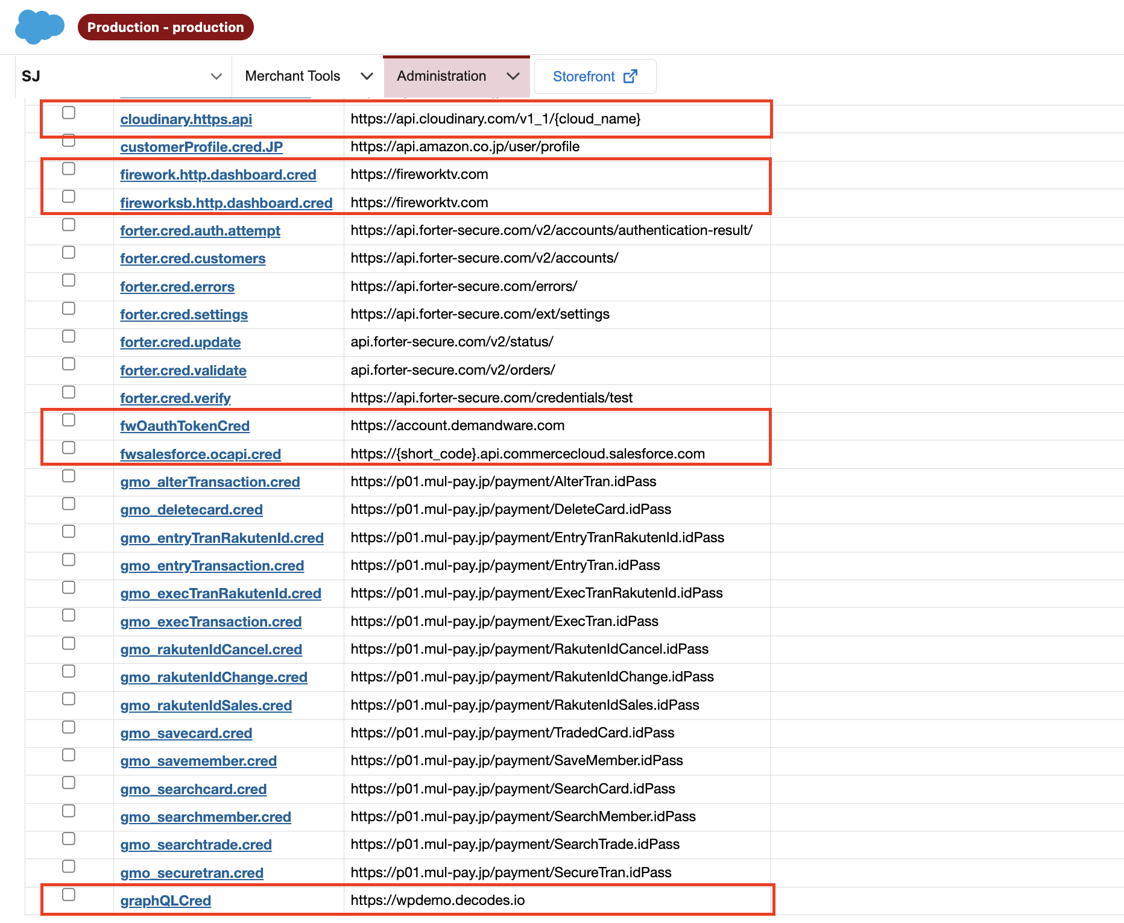

**Step 5 Existing Firework Jobs:**

Navigate to **Administration > Operations > Jobs** and delete following job:

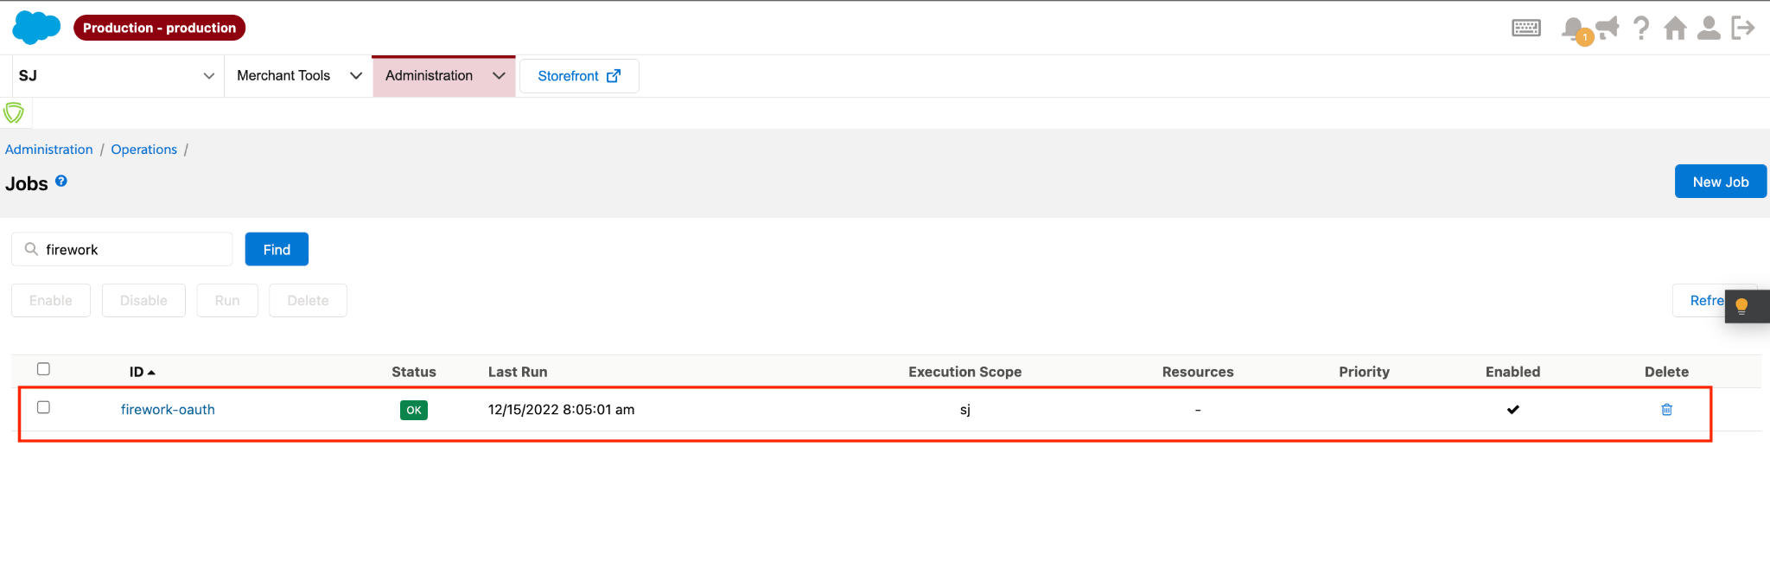

**Now please download the latest version of cartridge and install.**

# Operations, Maintenance

## Availability

The Firework widgets, being asynchronous, gracefully degrades and doesn’t block the loading of any page element.

## Support

Please contact Firework at [*ruturaj@fireworkhq.com*](mailto:ruturaj@fireworkhq.com)